Chapter 5, Problem 10

Find the gain v_{o}/v_{s} of the circuit in Fig. 5.49.

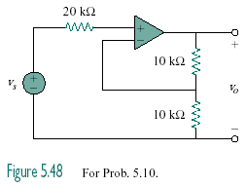

Figure 5.49
For Prob. 5.10.

